# HEX BARON – Class Diagram Tasks

# Task 1 (2 marks)

A partially-complete UML class diagram for the Player class is shown below.

Fill in the missing details.

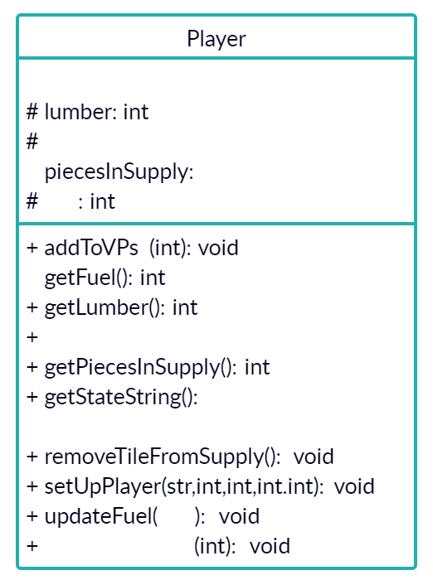

# Task 2 (5 marks)

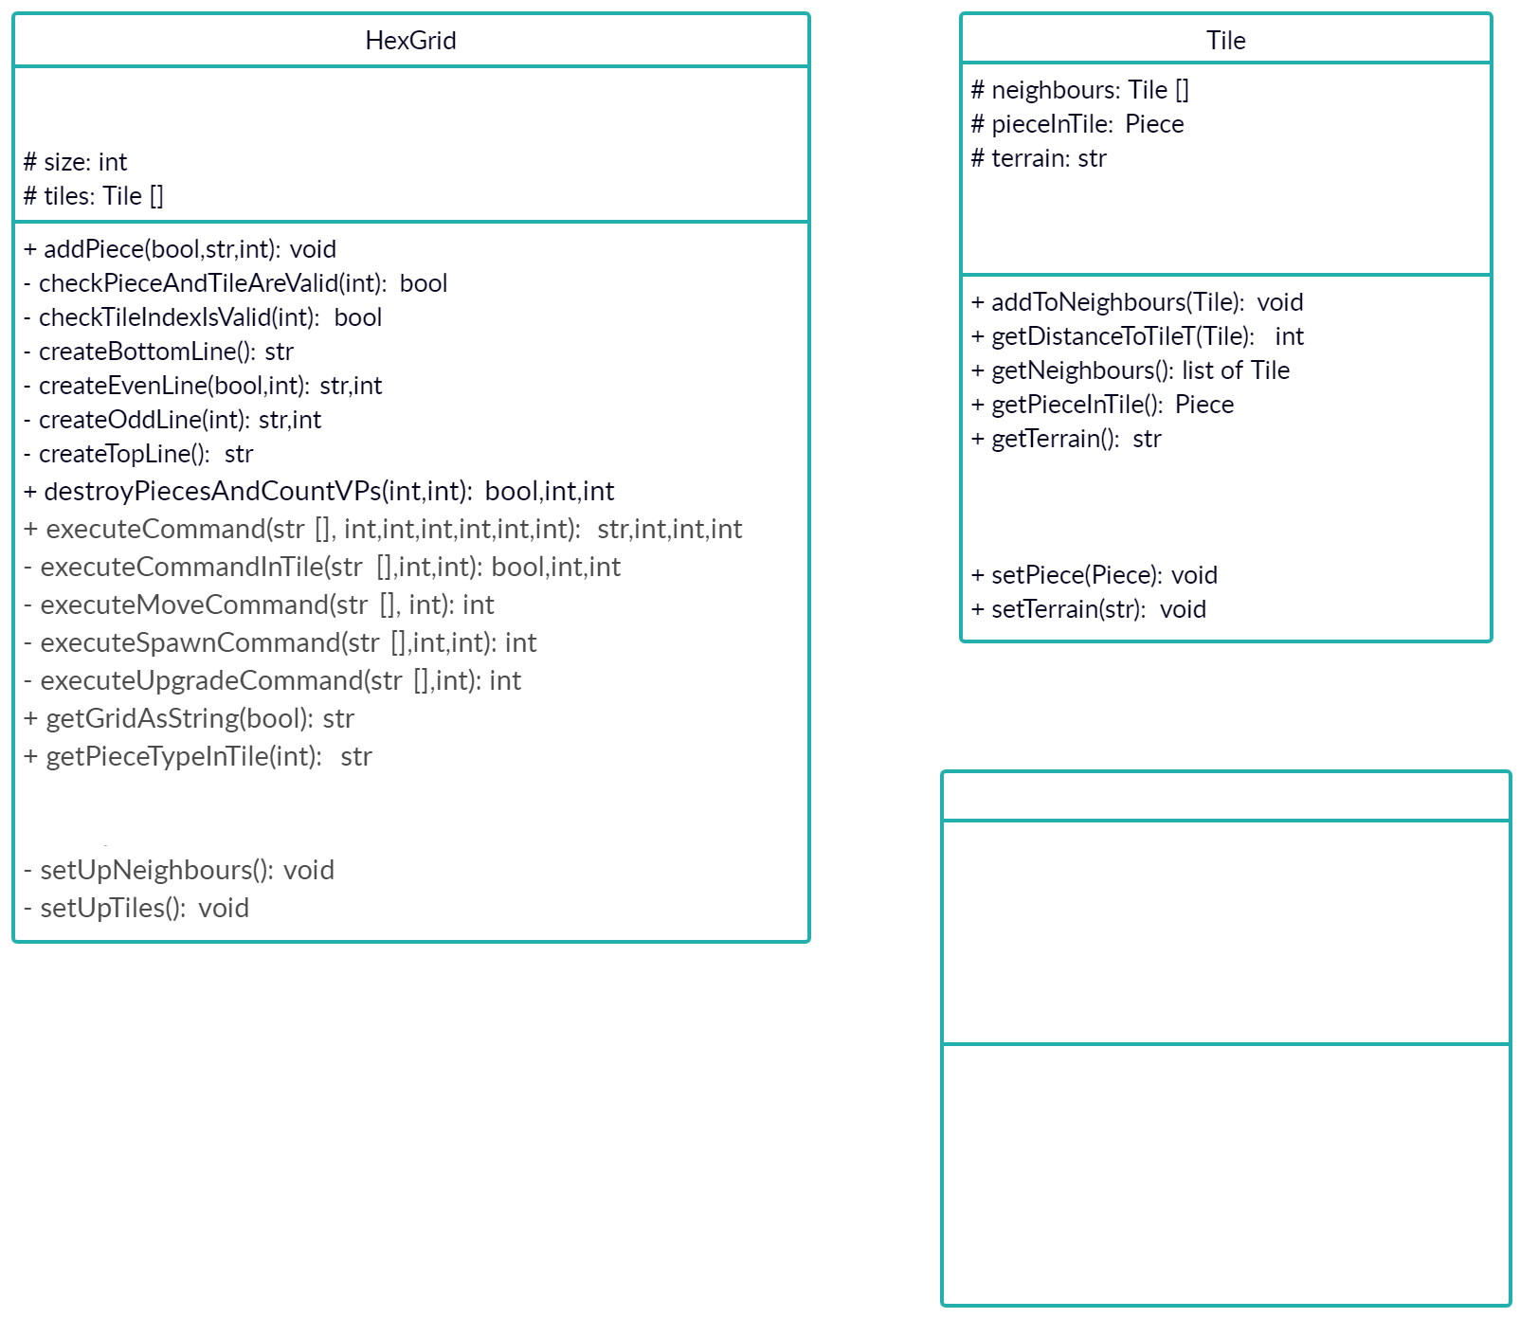

A partially-complete UML class diagram is shown.

Fill in the missing details, including any relationships between the classes shown.

# Task 3 (4 marks)

There are two pieces of information missing from the UML class diagram below.

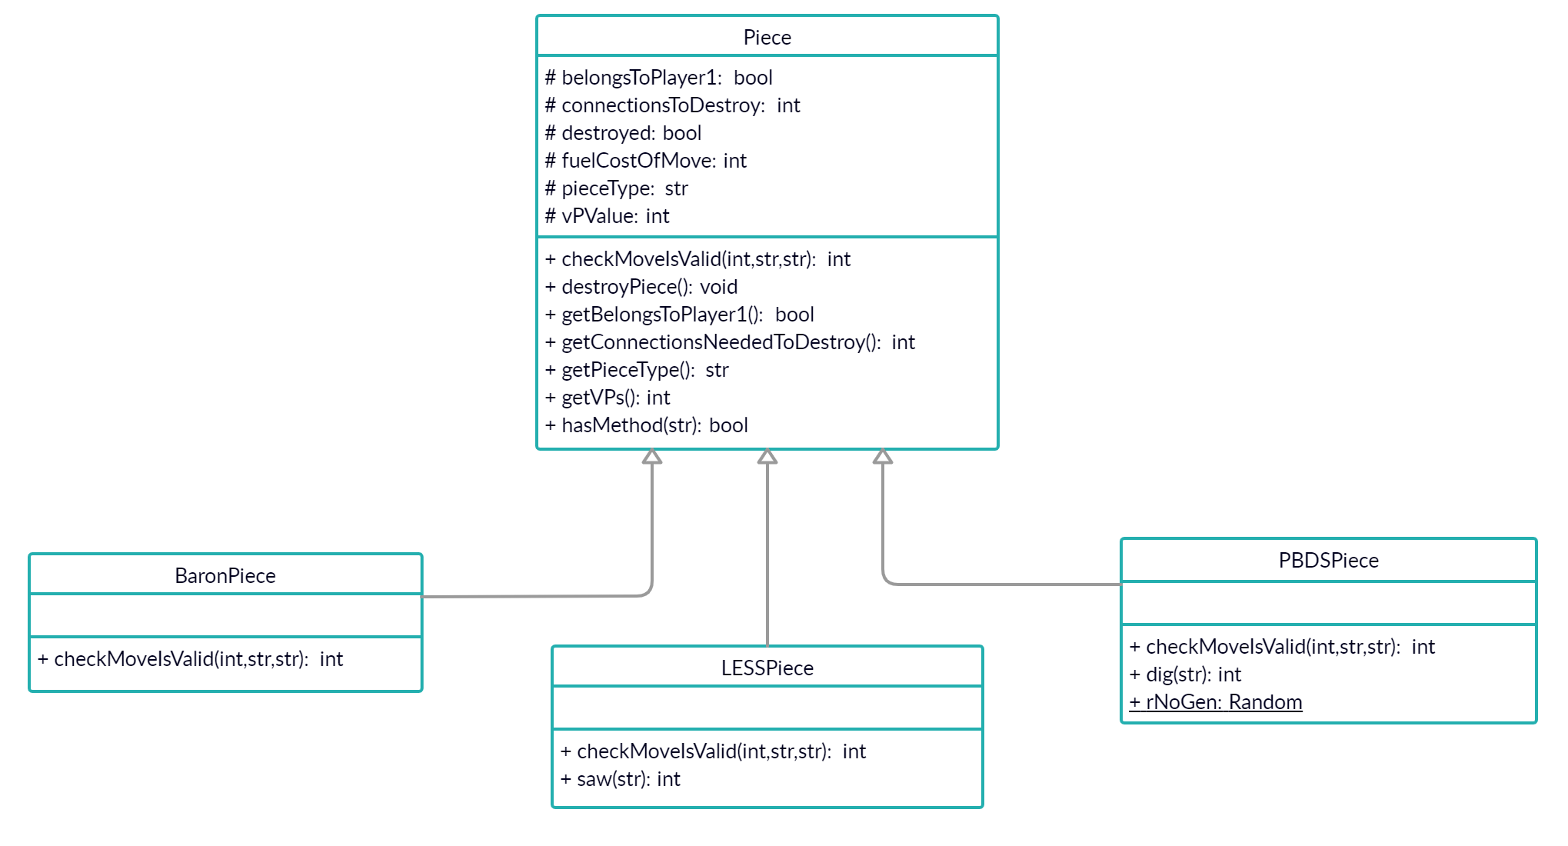

Explain what are they and why are they normally omitted?